System Security: Lab Manual

MS Cyber Security

ITU Lahore


Submitted to: Muhammad Shehryar Raza

Submitted By: Eisha Nawaz

Roll No: MSCS22007

Lab 12: Network Session Hijacking via ARP Poisoning
Tools:
- Ettercap
- Wireshark
- Linux VMs

2. Scenario Description
A client accesses a web service over HTTP inside a local network.
An attacker wants to intercept credentials using ARP poisoning.

3. Group Roles
- Victim Client: Logs into HTTP site (UBUNTU)
- Server: Hosts vulnerable web service (UBUNTU)
- Attacker: Performs ARP poisoning (Kali)

3. Install Required Tools on attacker and victim Machines
On kali: etercap + wireshark
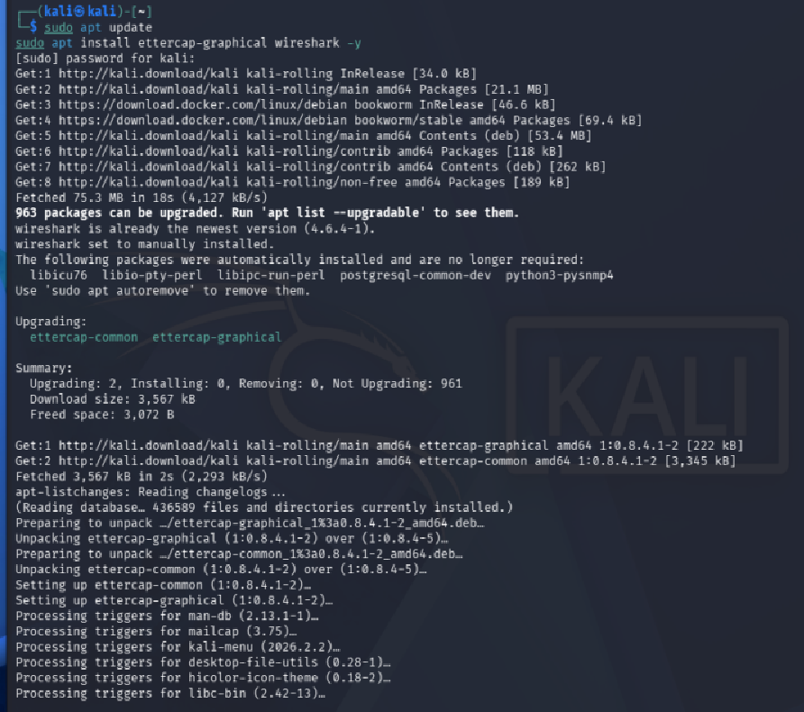
On Ubuntu: Install Apache + php + DVWA
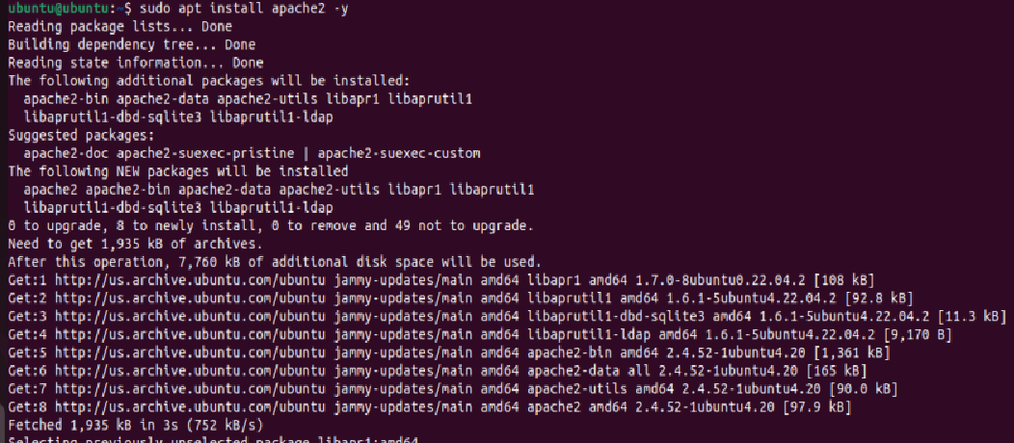
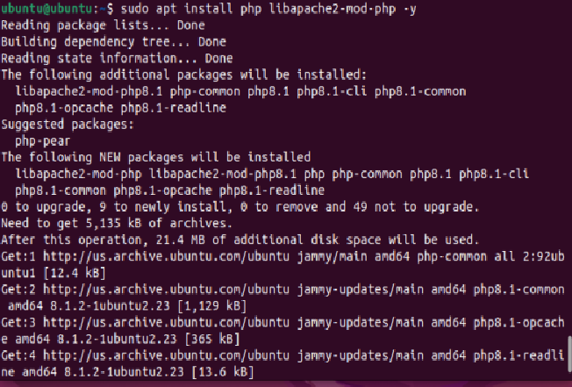
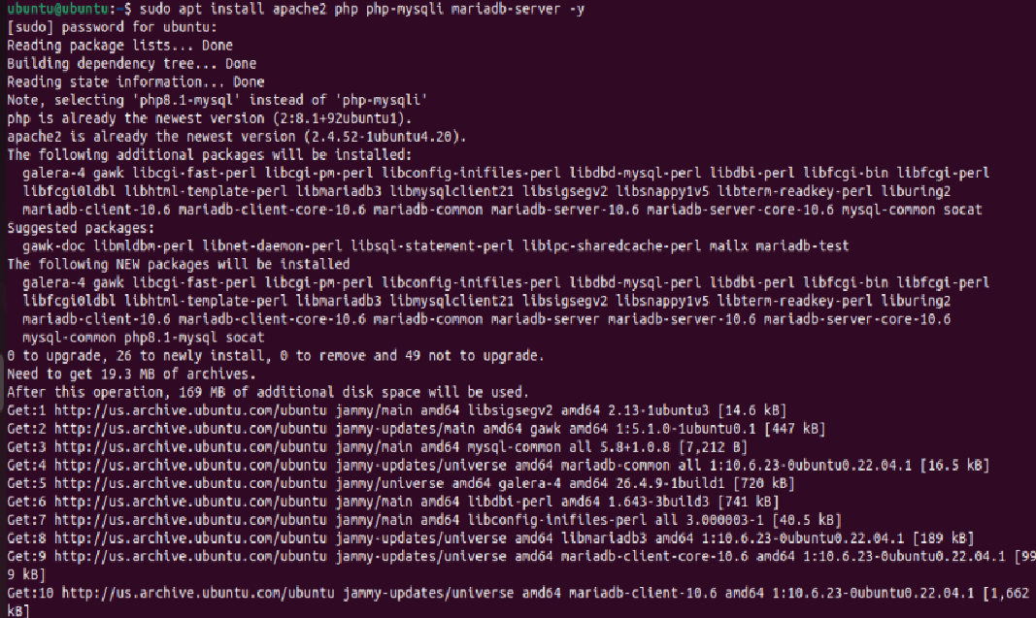

4. Environment Setup
Ensure:
- All VMs are on same subnet
- HTTP service running (DVWA / Apache)
Attacker VM
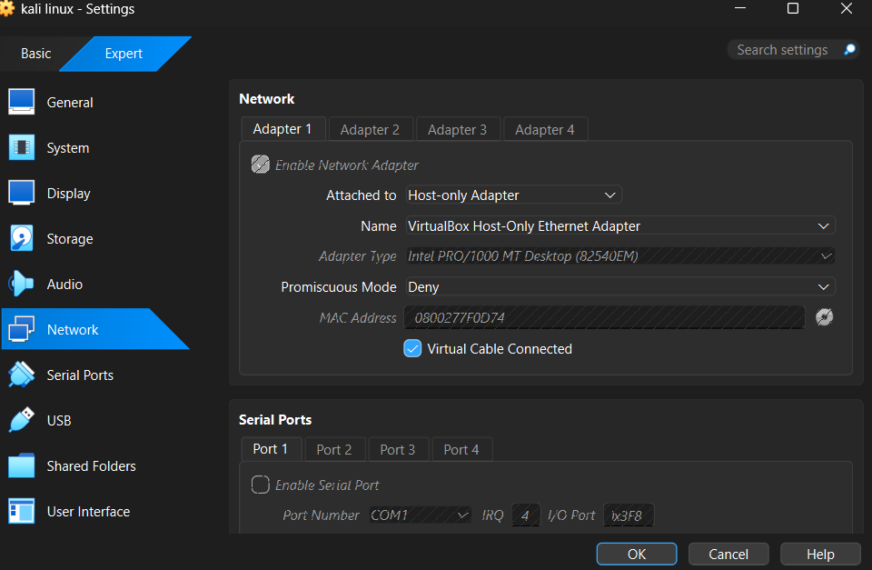
Victim VM
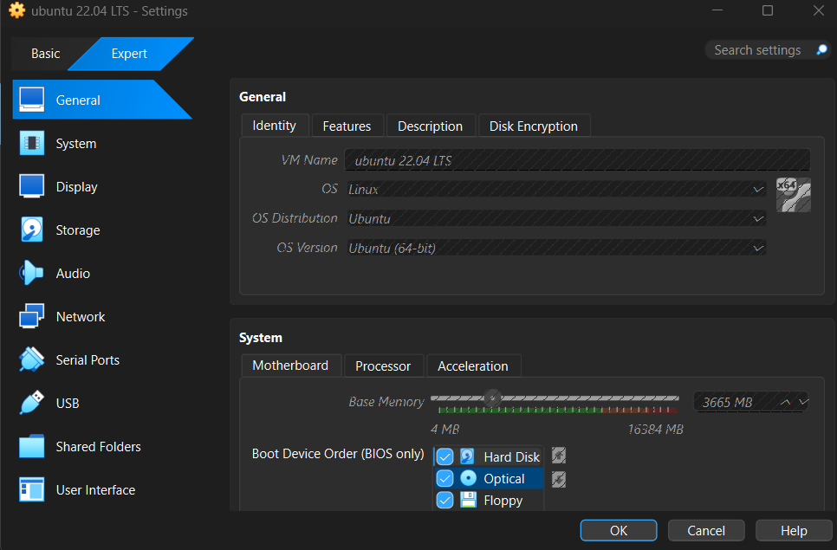
Attacker IP: 192.168.56.102
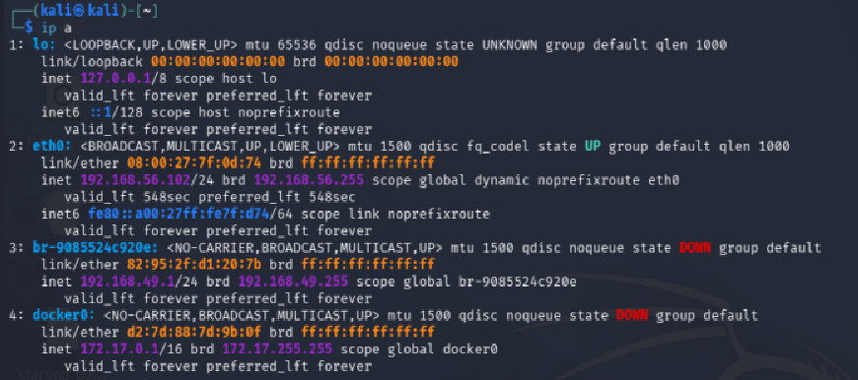
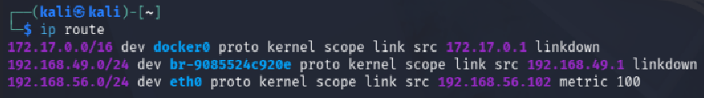
Victim IP: 192.168.56.101
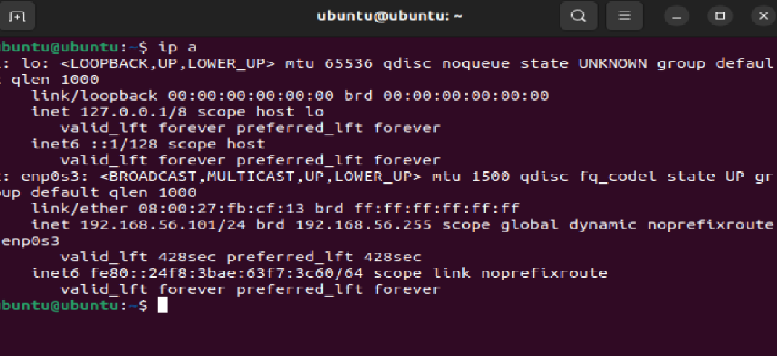
Ubuntu Gateway IP: 192.168.56.0
Test From Host Browser
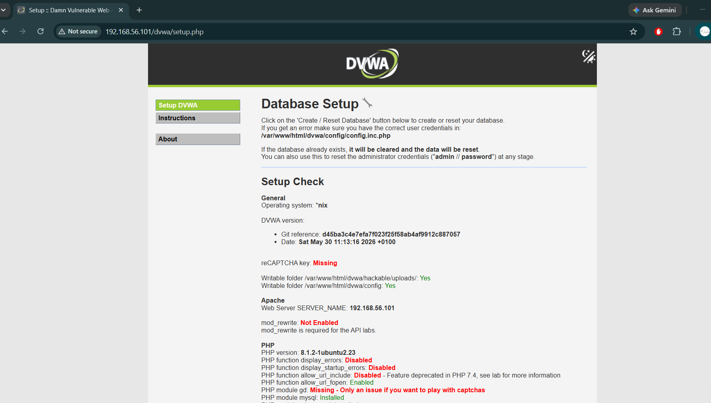
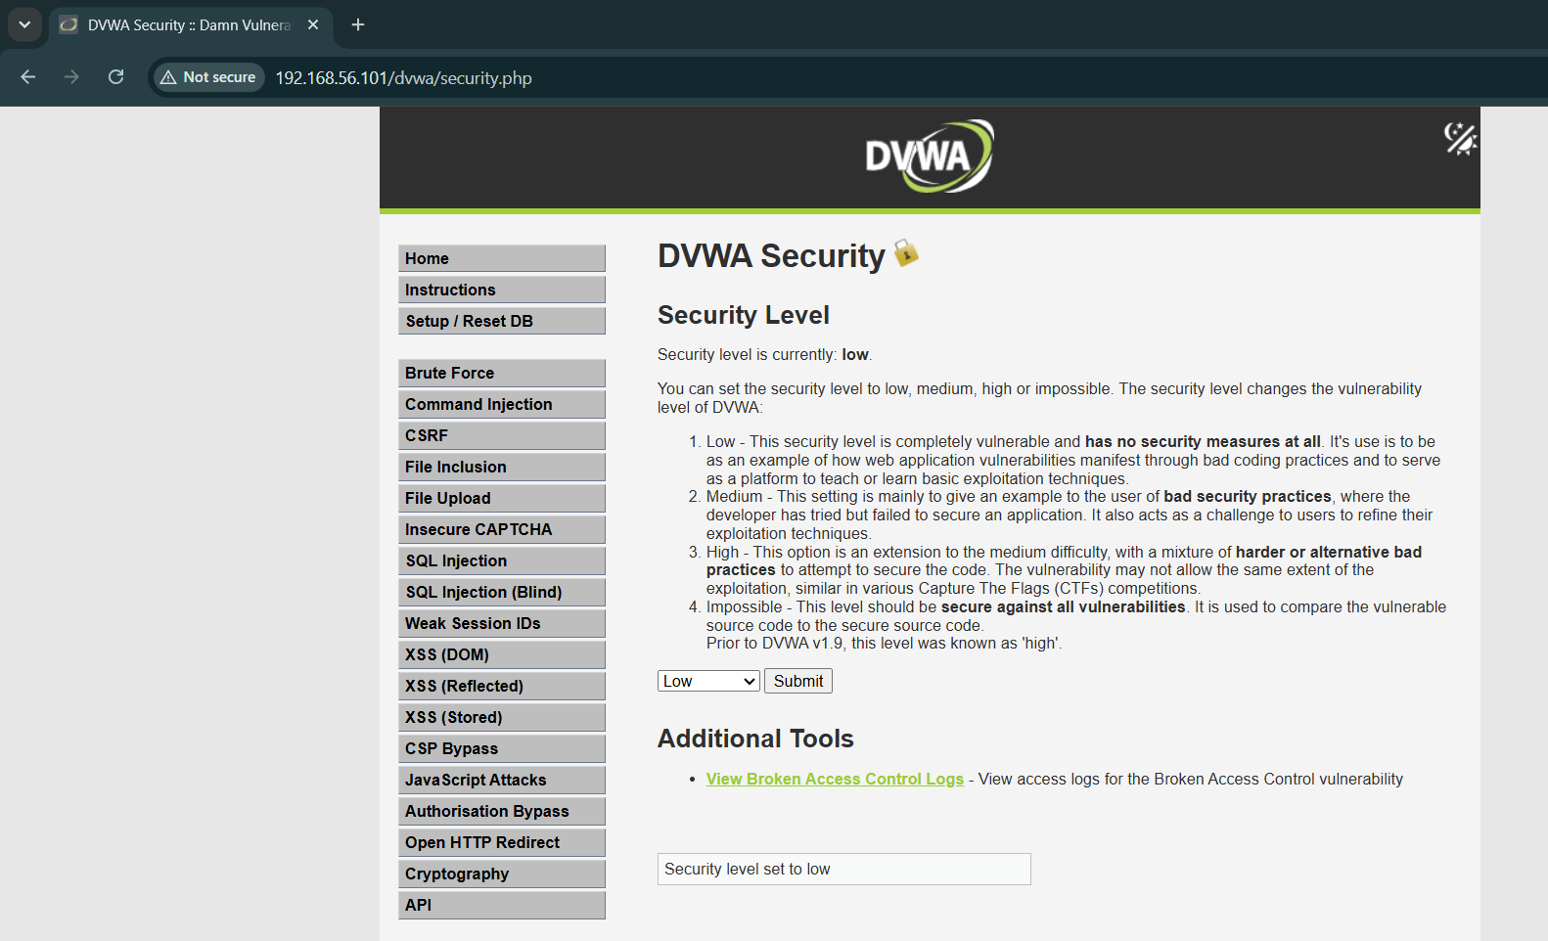
Enable IP forwarding (attacker):
echo 1 | sudo tee /proc/sys/net/ipv4/ip_forward
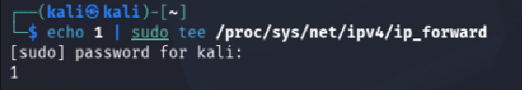

5. Step-by-Step Tasks

Task 1: Baseline Traffic Capture (15 minutes)
Start Wireshark on attacker:
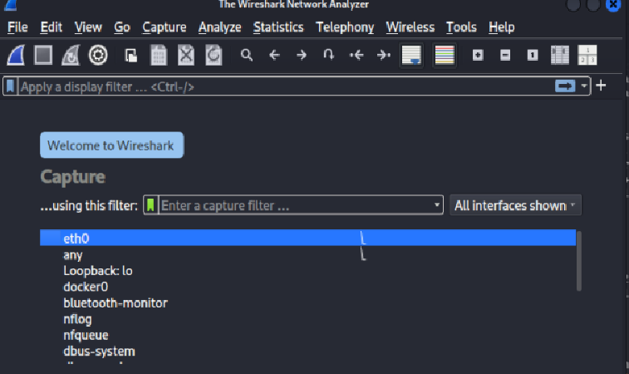
- Filter: http
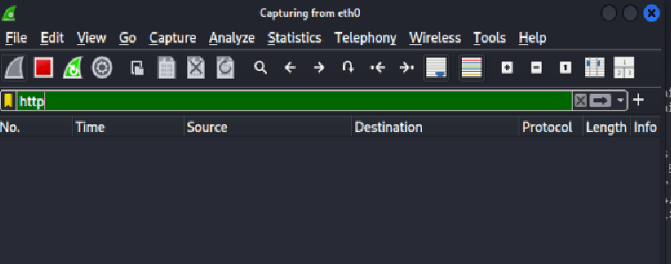
Find Victim IP on kali
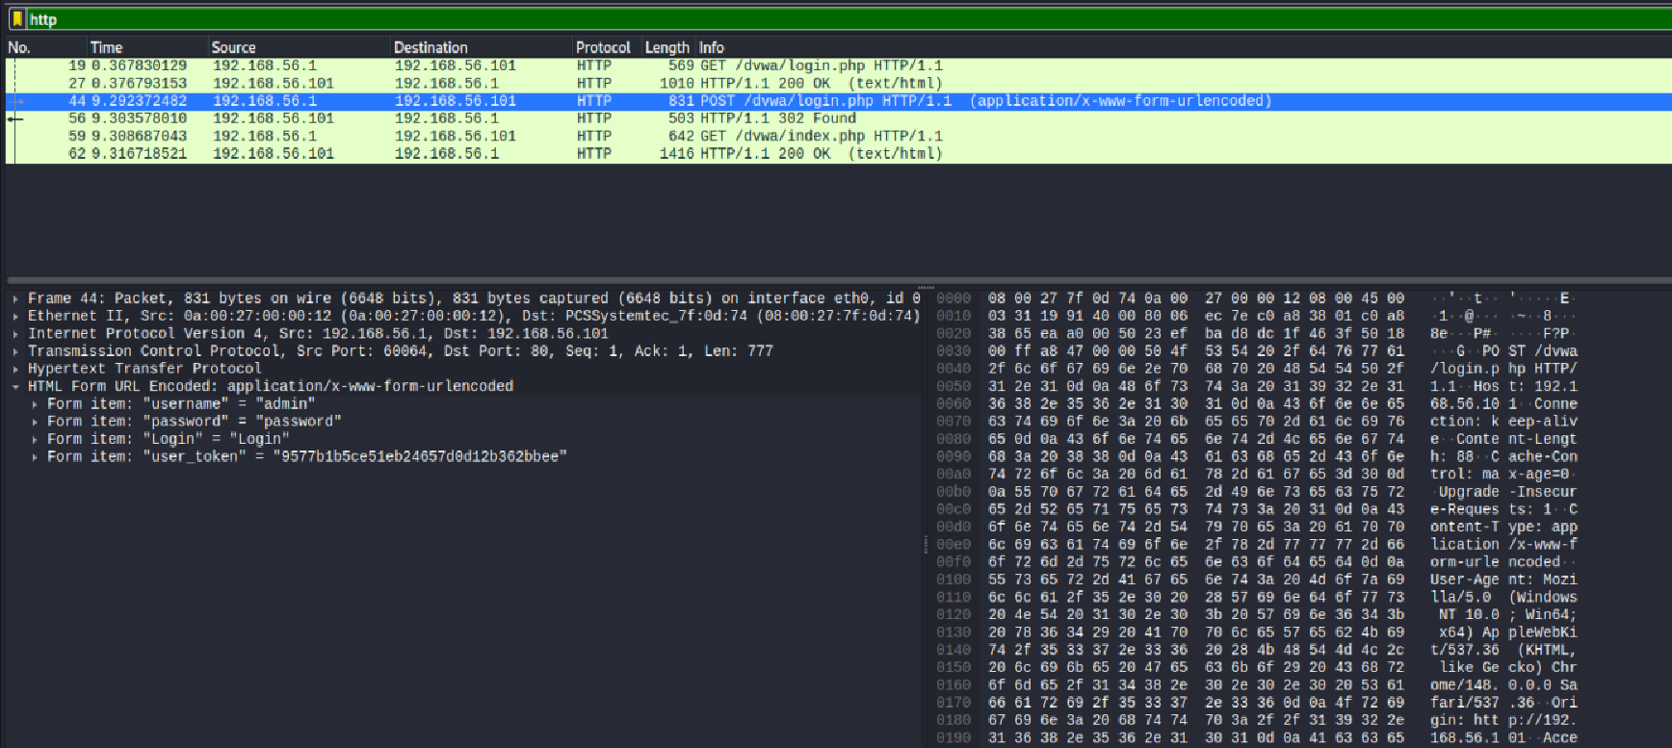
Client logs in normally.
Observe:
- Plaintext credentials

Task 2: Launch ARP Poisoning
Victim IP: 192.168.56.1
Gateway IP: 192.168.56.101
Run:
sudo ettercap -T -q -i eth0 -M arp:remote /client-ip/ /server-ip/ 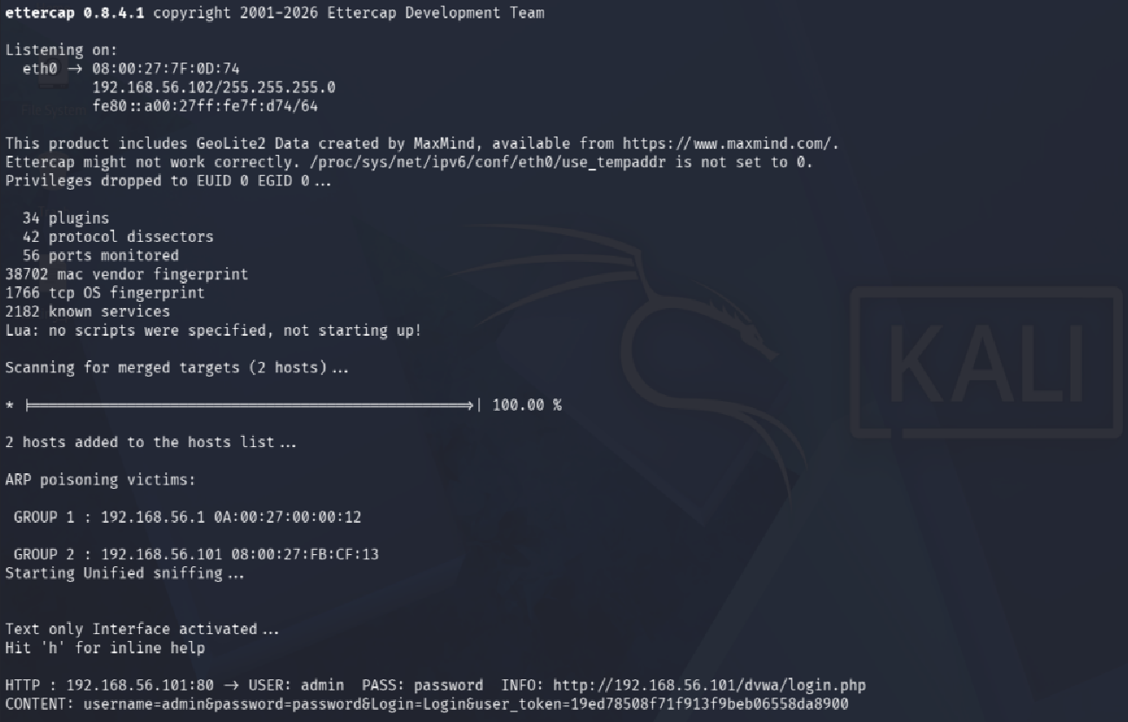
Observe ARP spoof messages.

Task 3: Capture Session Cookies (20 minutes)
In Wireshark:
- Filter: http.cookie
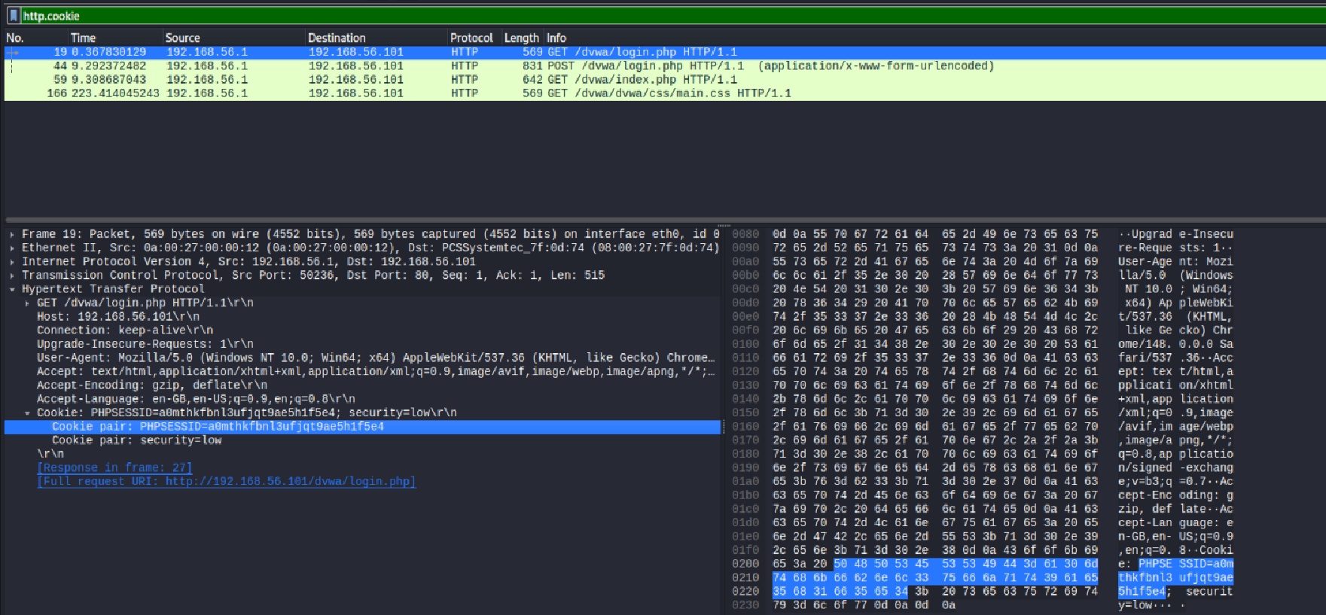
Identify:
- Session ID
- Authentication token

Task 4: Session Hijacking
Copy cookie into attacker browser:
- Use DevTools → Application → Cookies
Refresh page → access victim session.
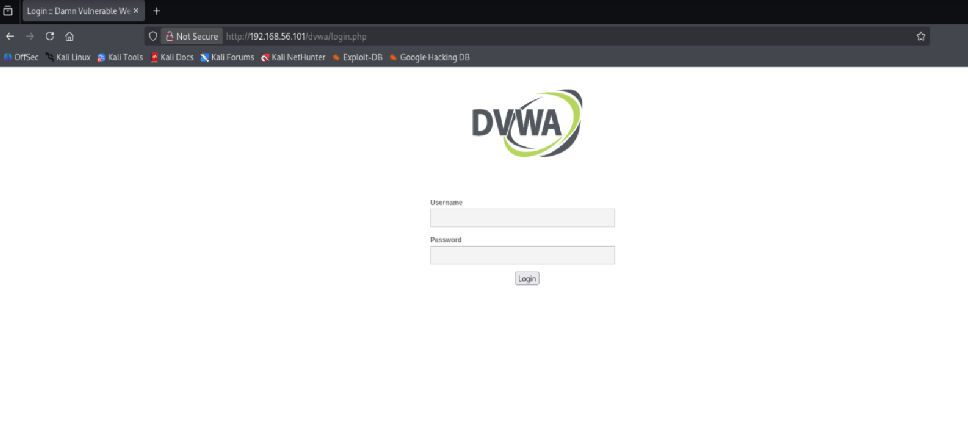
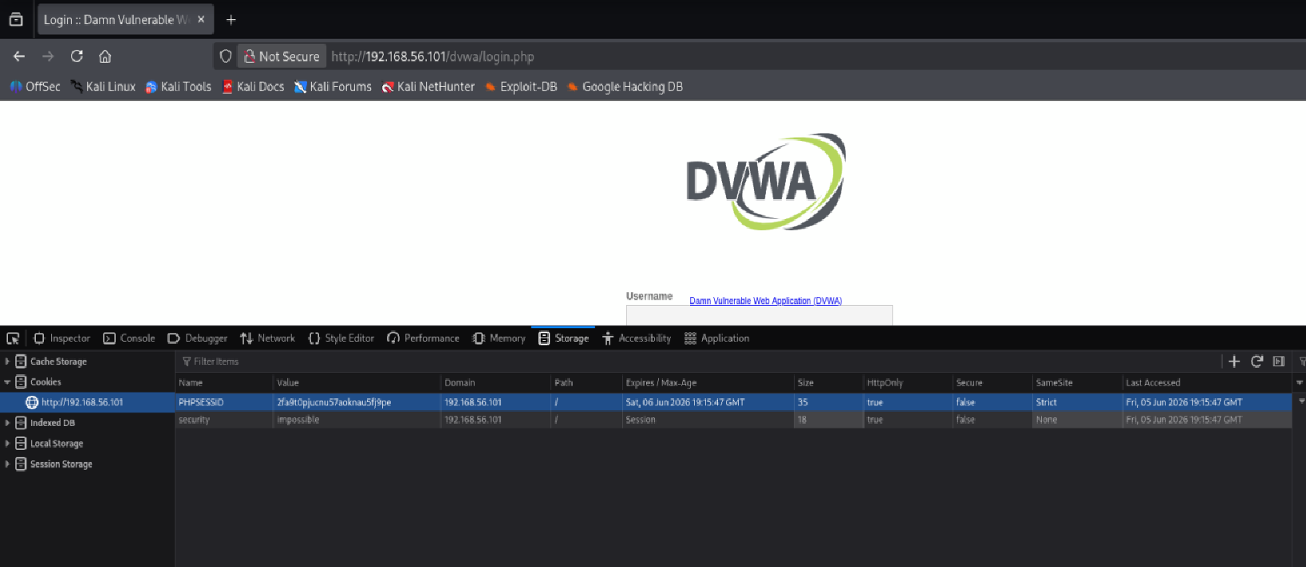

Task 5: Defense Discussion
Answer:
- Why HTTPS breaks this attack
Even with HTTPS, we can still sit in the middle and grab the packets but they're scrambled. HTTPS locks the credentials and the session cookie inside encryption that only the victim's browser and the real server can unlock, so all we see in Wireshark is gibberish. There's no readable cookie to steal or replay. The only reason my attack worked is that DVWA was running on plain HTTP, which sends everything in the open.
- Why LAN ≠ trusted
Being on the same network as someone doesn't mean they're safe. Any machine on the network can lie about who it is and quietly slip into other people's conversations, no special access needed. "Inside the network" doesn't mean "trusted," which is why modern security assumes every connection could be hostile and protects each one with encryption instead of relying on a safe-feeling perimeter.
- Why ARP has no authentication
ARP was built to be simple, back when nobody worried about attackers. It just asks "who has this IP?" and believes whatever answer comes back, no ID check, no proof. A machine will happily update its records with a fake answer, even one nobody asked for. That blind trust is exactly what let your Kali box pretend to be the server and reroute the victim's traffic through itself.

